Week 6 Assignment Answers
GIT HOL
Question 1:
Opened Github

To Create New Repository
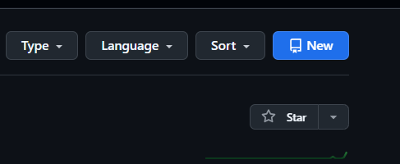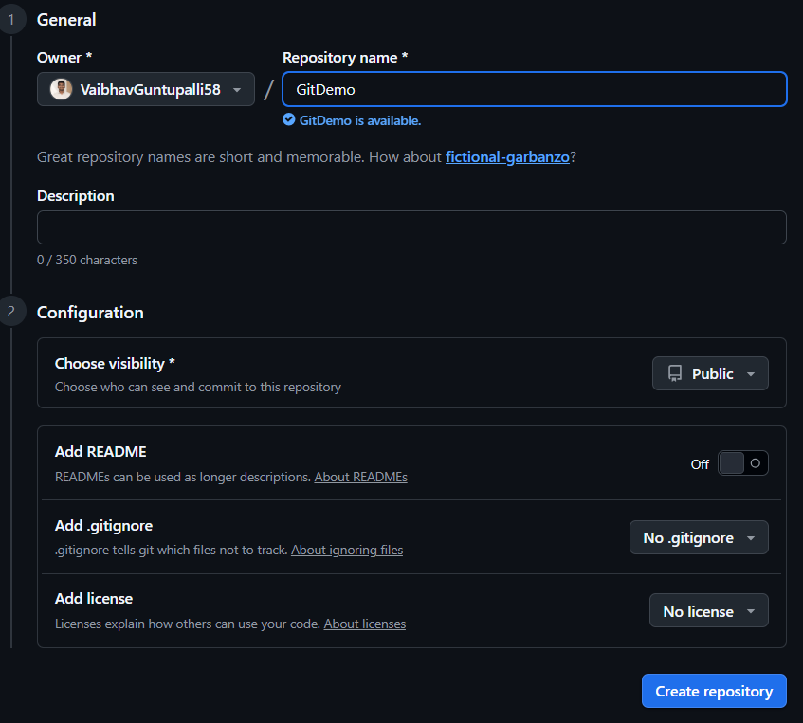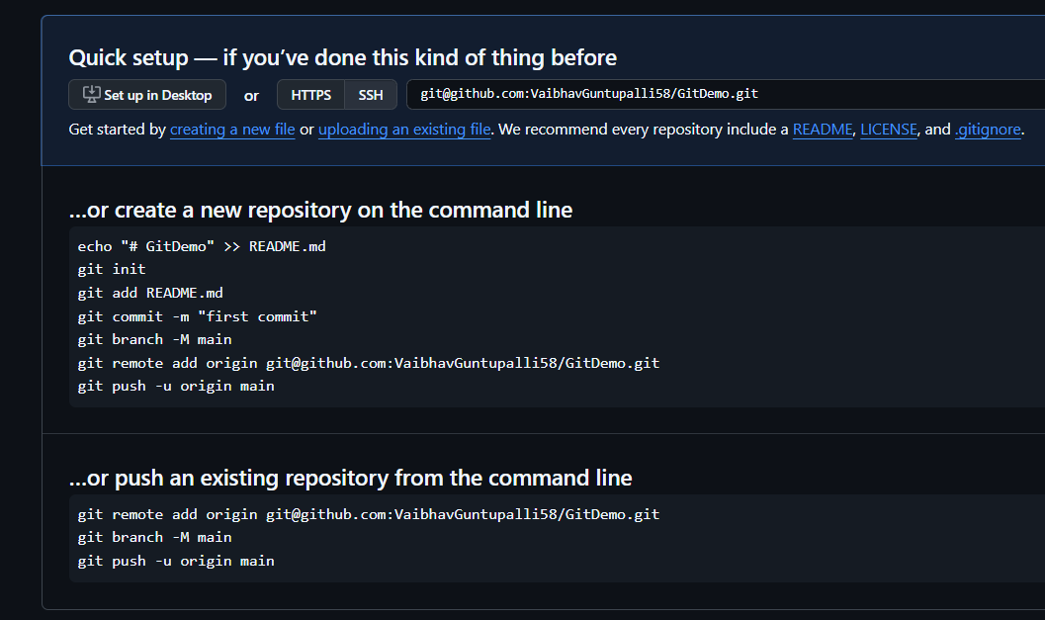
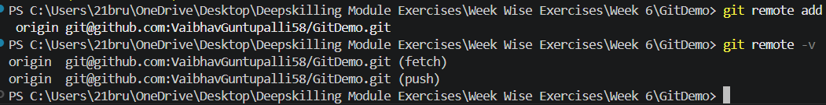
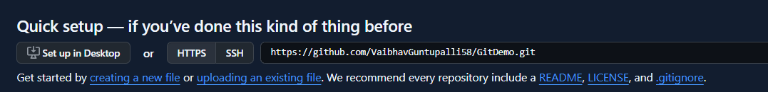
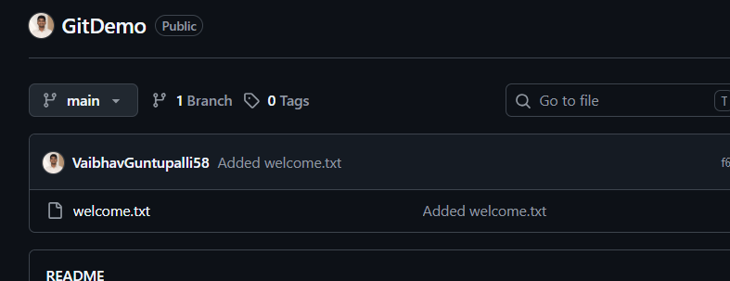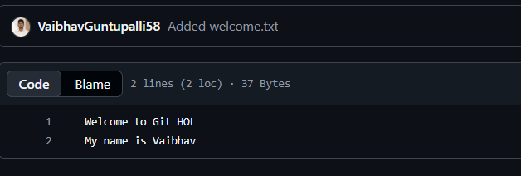

Question 2
Create hello.txt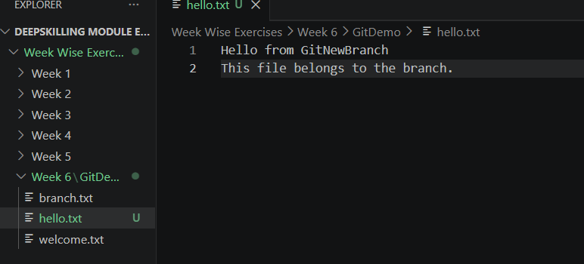
Check status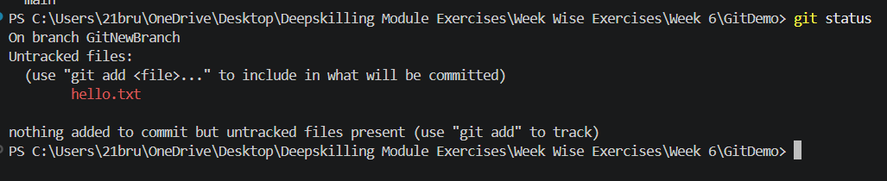
Stage the file, Commit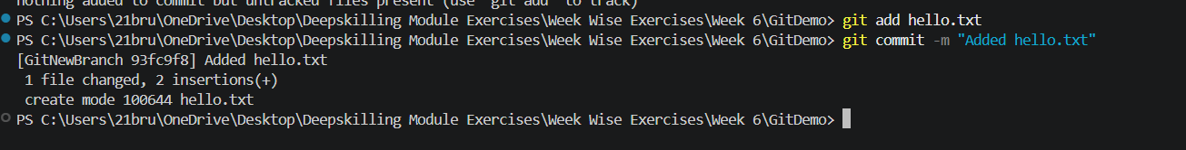
Switch back to main

Compare the branches
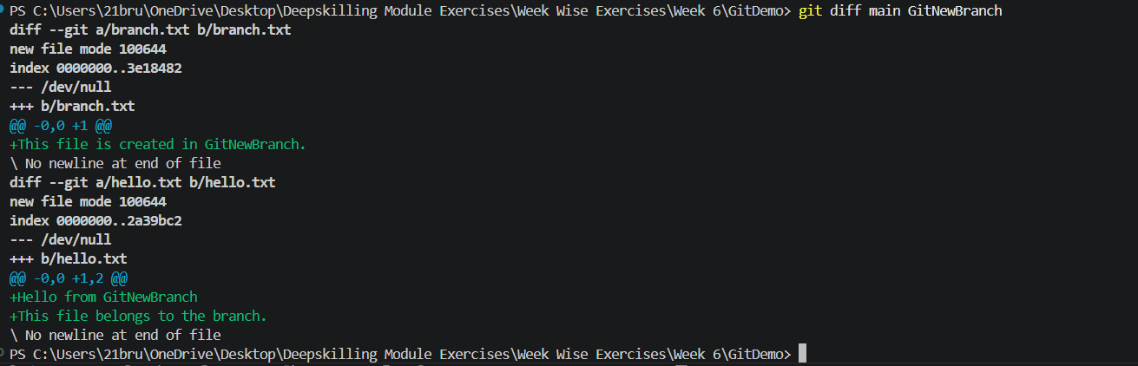
Merge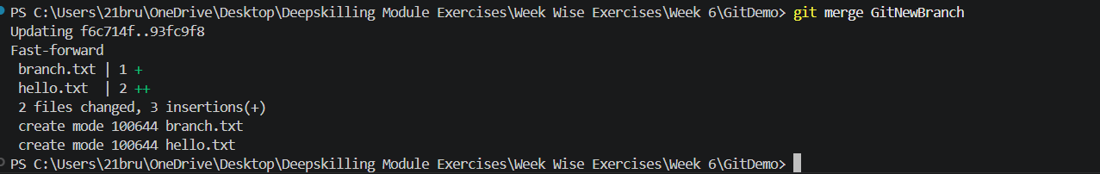
View commit history
Delete the merged branch, Verify

Question 3
Go to main
Create a new branch, Create hello.xml, Create status, Commit
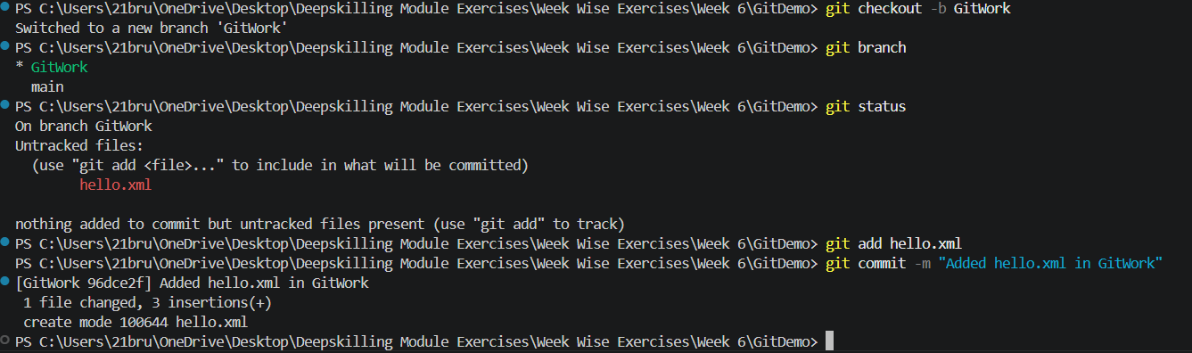
Switch back to main, Modify the hello.xml file, Commit on main
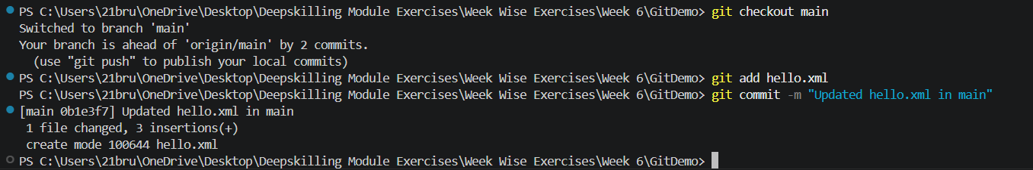
View history
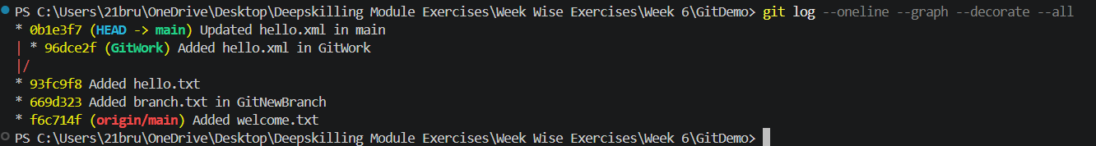
Compare branches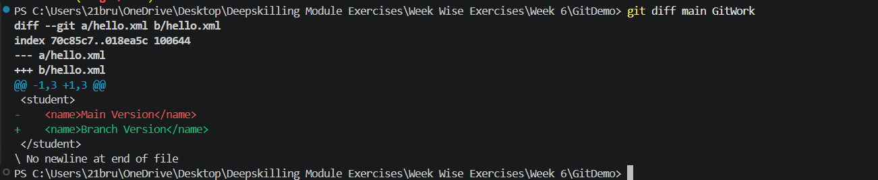
Merge
Before Resolve
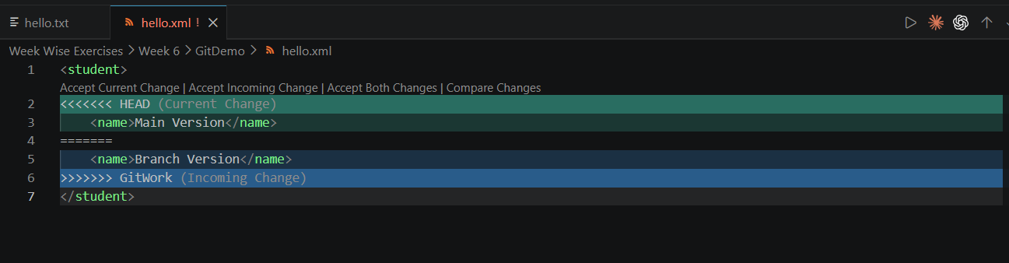
After Resolve
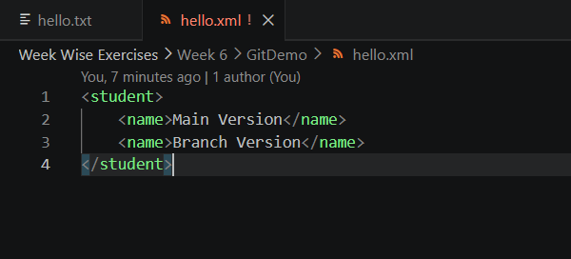
Create .gitignore, Commit .gitignore, Delete the branch, Final Log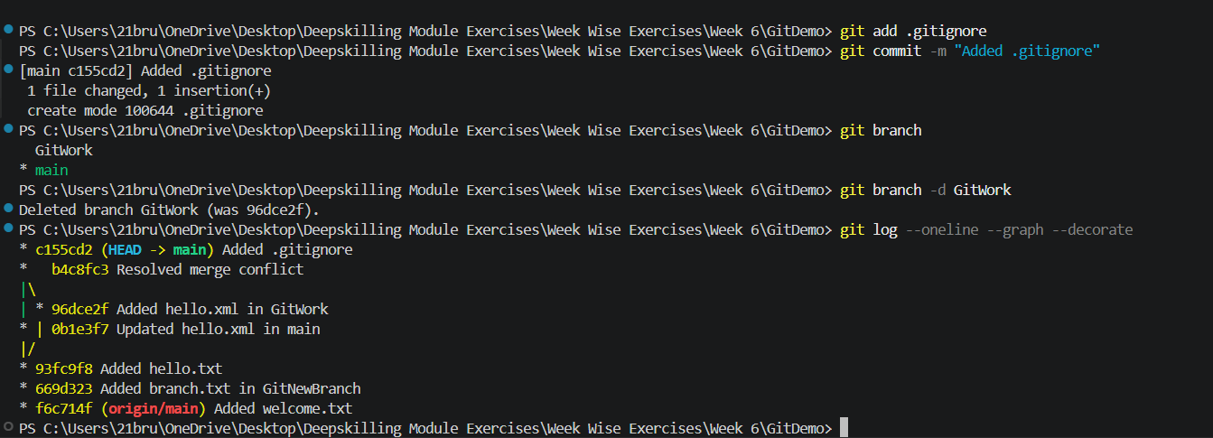

Question 4
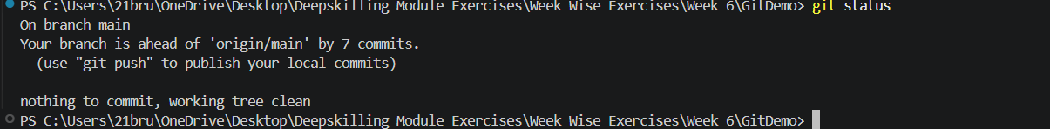

Question 5
